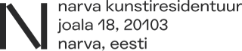
NARVA ART RESIDENCY ⎜ OPEN CALL FOR FINNO-UGRIC CREATIVE RESIDENCY 2025 ⎜ APPLICATION FORM
NAME OF ARTIST OR DUO

I am / We are applying as a
Single artist
Artistic duo

Date of birth

Nationality

Country

Occupation

Phone number

Email

Website or link to portfolio

Primary art form
(visual art, architecture, performing art, film, writing, research etc.)

Where did you hear about NART or this open call?

Introduction and short bio (max 300 words)

Motivation (max 300 words)

Residency project description (max 500 words)

Additional information, requests for the residency

A few images with examples of your work (if applicable)

